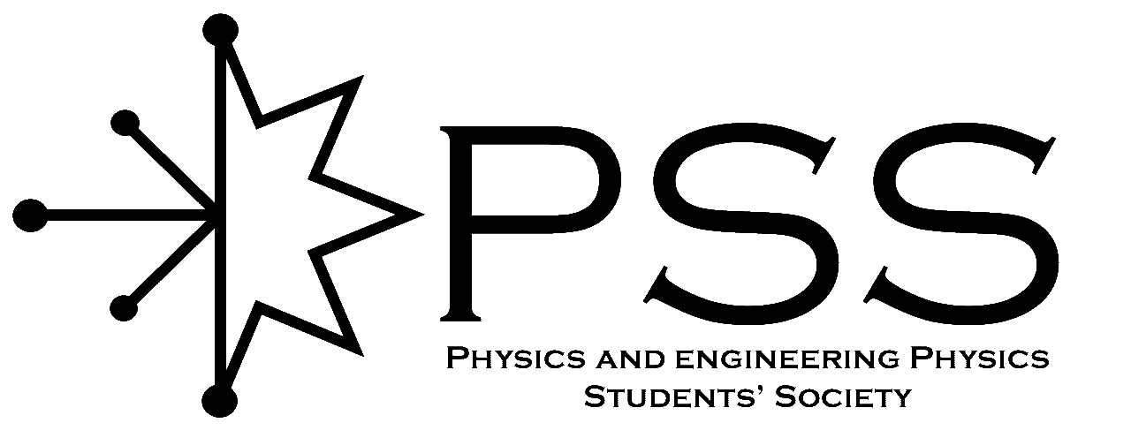
Conference Funding Assistance Application (CFAA)

Name: Click or tap here to enter text.
NSID: Click or tap here to enter text. Email: Click or tap here to enter text.
Current Degree Program: Click or tap here to enter text.
Conference Attending: Click or tap here to enter text.
Date(s): Click or tap here to enter text. Location: Click or tap here to enter text.
Other funding sources: Click or tap here to enter text.
Will you be presenting as part of this conference? Yes No
If yes, how will you be presenting? Poster Talk
Once this form has been processed by the PSS Executive you will be contacted at the email address you provided above. If your application is approved you will be informed of your maximum reimbursement amount. Approved costs include conference registration and travel. Present all relevant receipts/invoices after the conference to receive your reimbursement.

Applicant Signature: Date:
To be filled out by PSS Executives

Approved? Yes No Executive Signatures:
Amount, up to:
After conference Reimbursement amount: Cheque #:

