BIOL380 – Which hats to urchins prefer? – Webster/Ivy labs
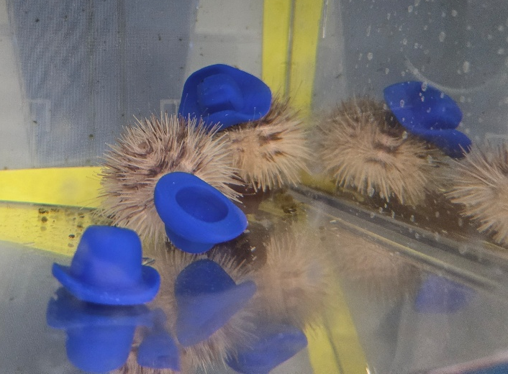
In the wild, sea urchins regularly cover themselves with debris, possibly as camouflage. The Webster lab helps raise a colony of sea urchins, and we want to know what properties are preferred for our sea urchins. We will use 3D printing to modify shape, density, size, and colour to determine what enrichment might be preferred by the sea urchins.
For more information please contact me:
Nicole.webster@usask.ca
Dr. Nicole Webster

