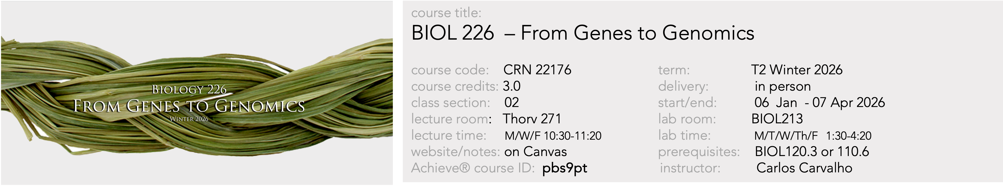

Course Syllabus – Winter 2025

Land Acknowledgment
The Saskatoon campus of the University of Saskatchewan is on Treaty Six Territory and the Homeland of the Métis. We pay our respect to the First Nation and Métis ancestors of this place and reaffirm our relationship with one another.

Calendar Description
Content ranges from Mendelian genetics to molecular biology to population genetics. Examples from eukaryotic species, including humans, are emphasized. Topics include classical transmission genetics, cytogenetics, transcriptional regulation, gene function, mutation, DNA repair, recombinant DNA technology and structural/ functional/comparative genomics.

Learning Context and Attendance Expectations
Lectures and laboratories for BIOL226 will be delivered 100% in person for the Winter 2026 term. There will be no video recording of lectures available to students. There will also be no make up lectures or labs. While attendance is not mandatory, students are expected to be present in all lectures and labs. Up to 3% of marks in this course will be distributed based on participation during lectures using Poll Everywhere (see below).

Course Overview
BIOL226 is an introduction to the basic genetics concepts that permeate several fields in the biological and health sciences and is intended to prepare students for senior molecular biology and genetics courses. The course combines classical genetics with molecular and genomics analysis. The first half of the course focuses on Mendelian genetics as it relates to the Chromosomal Theory of Inheritance. Practical applications of classical genetics principles such as genetic linkage, pedigree analysis and recombination in building genetic maps are explored. In the second half, we turn to understand the fundamental molecular processes behind the Central Dogma of Molecular Biology that coordinates the flow of genetic information through biological polymers, the origin of mutations and how genomes are functionally organized. We then move to investigate how the genome is transcriptionally regulated to yield variation at the level of the phenotype both genetically and epigenetically. The course ends by addressing questions in population and evolutionary genetics.

Note: The University of Saskatchewan Learning Charter is intended to define aspirations about the learning experience that the University aims to provide, and the roles to be played in realizing these aspirations by students, instructors and the institution. A copy of the Learning Charter can be found at: https://teaching.usask.ca/documents/vptl/LearningCharter.pdf.

Learning Outcomes
By the completion of this course, students will be expected to:
- Be able to explain the genetics laws governing heredity.
- Be able to solve basic pedigree analysis questions.
- Understand the basics of genetic analysis at the gene and genome levels.
- Understand the functional organization of prokaryotic and eukaryotic genomes.
- Understand basic principles of gene expression and gene regulation mechanisms.
- Be able to solve basic questions on changes in allele and genotypic frequencies in populations.

Instructor information:

Instructor: Carlos Carvalho
Contact info:
Office: room 225 CSRB
Ph# 966-4436
Email: carlos.carvalho@usask.ca
Lab Coordinator: Andres Posso-Terranova
Contact info:
Office: room G77 THORV Building
Ph# 966-4431
Email: andres.posso@usask.ca

Dr. Carvalho is a regular faculty member in the Department of Biology. He holds an MSc in molecular biology (Japan) and a PhD in molecular genetics (Canada). Dr. Posso-Terranova is a laboratory coordinator for genetics courses in the Department of Biology. He holds a MSc in plant breeding (Colombia) and a PhD in evolutionary genetics (Canada).
Office Hours: Please note that all instructors have other commitments that may take them away from their office. Specific appointments can be set by email only.

Resources
- Textbook: ‘Introduction to Genetic Analysis’ – 12th edition. Griffiths et. al. 2020. Purchase of the textbook is encouraged, but not required. The ebook license with Achieve is available through the bookstore: (https://shop.usask.ca/CourseSearch/?course[]=UOFS,202501,BIOL,BIOL226,01&). Achieve is an online platform with several learning resource features. The textbook should help students to prepare in advance for lecture and as a resource in studying for exams, it should not be used as a substitute for lecture notes and attendance.

- Lecture notes (pptx files) and other online resources will be posted and accessible through the Canvas course page. Using Canvas students can also engage in course discussions about the course material and contact the instructors.

- Poll Everywhere®, a free web-based student response system that is accessed through an app downloaded to a cell phone or via a webpage. This tool will be used to gauge the understanding of concepts taught during lecture and quickly address gaps, encourage student engagement, and foster discussion. More information in the first lecture of the course.

- Achieve® online assignments. A license for Achieve is included with purchase of the ebook (course ID: pbs9pt). Assignments will be accessible in the window of time indicated in the schedule table below. For extra marks to be considered (see course marks below) assignments must be submitted exclusively online by the indicated deadlines. Please note that no deadline extensions will be given. Students have an unlimited number of attempts in answering Achieve questions. Once submitted, however, assignments cannot be retrieved and modified by the student.

Lecture Topics

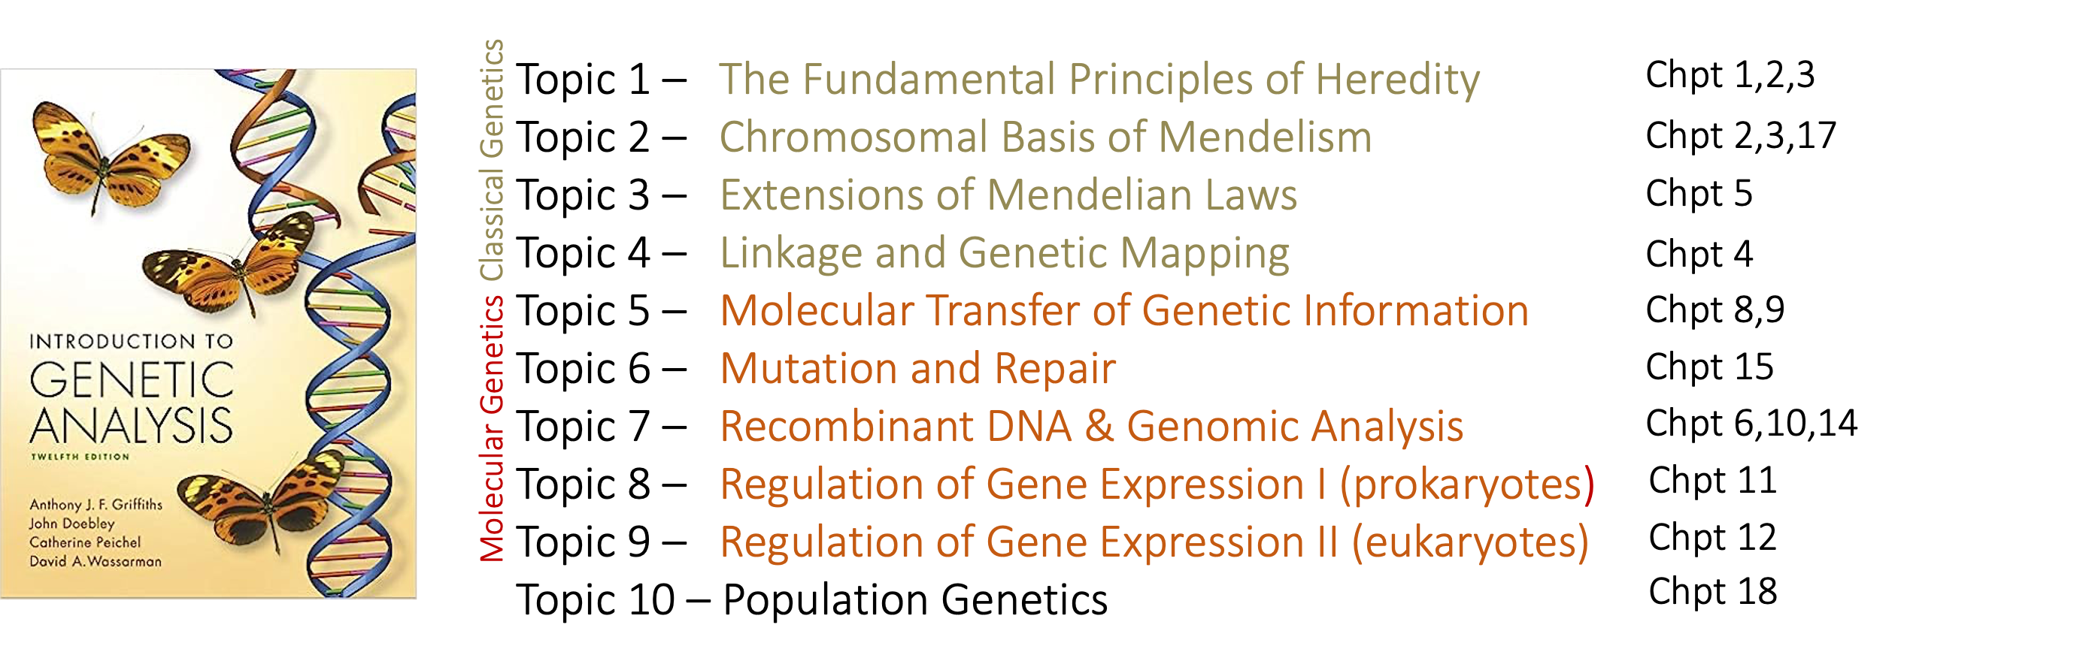

Lecture Schedule (putative)

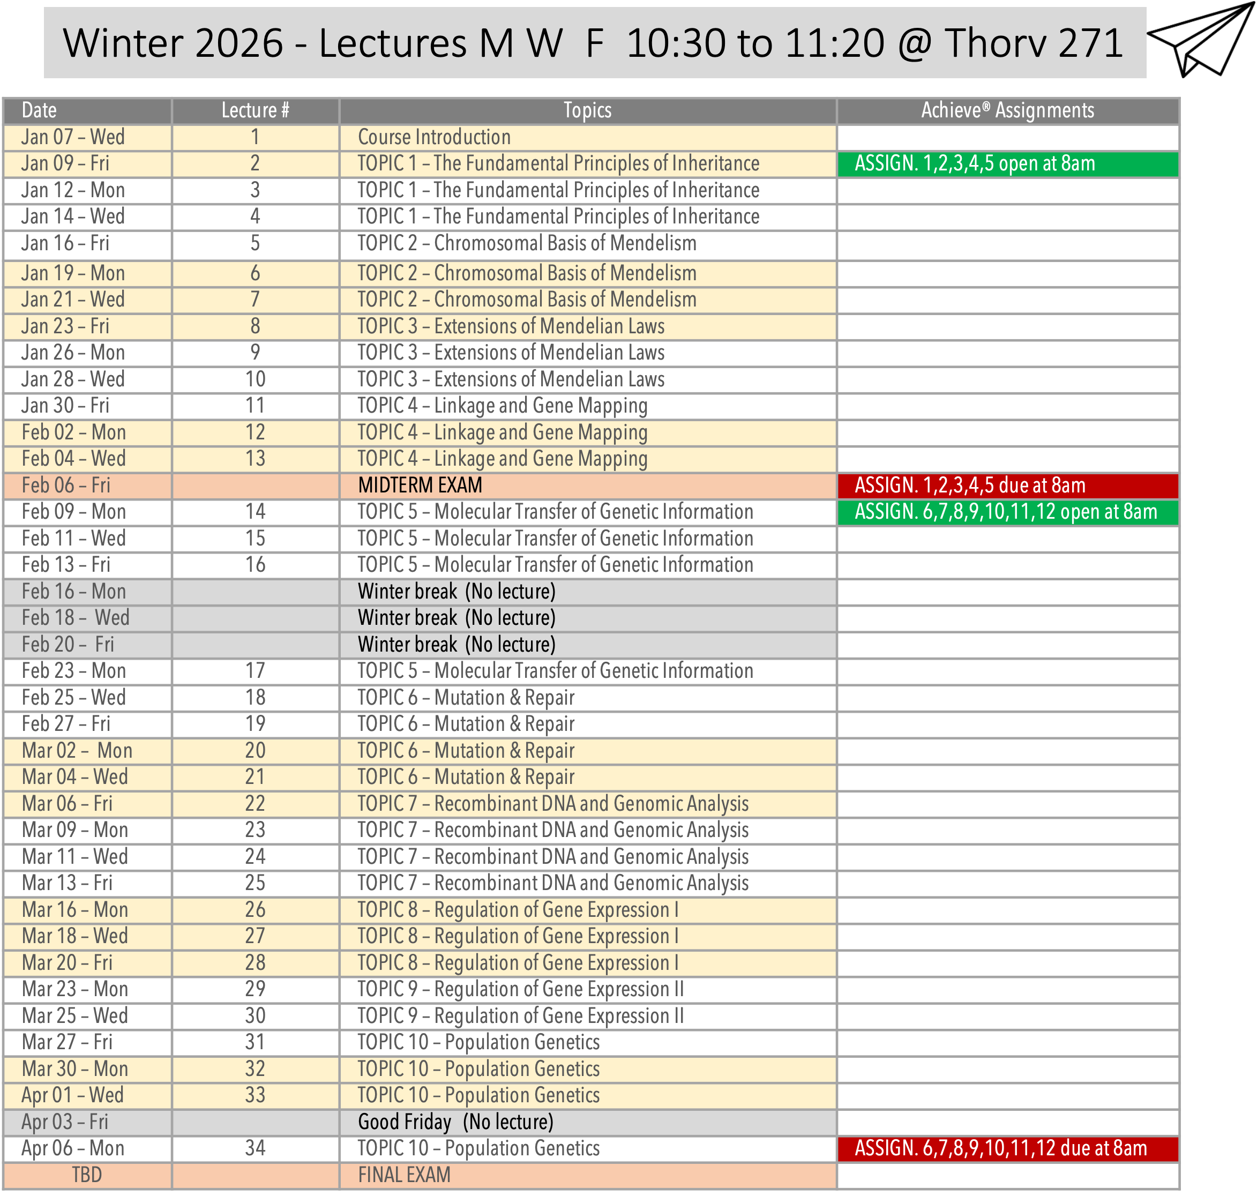

Laboratory Schedule
Each student is required to purchase an access code from the U of S campus bookstore for downloading the lab book: https://shop.usask.ca/CourseSearch/?course[]=UOFS,202309,BIOL,BIOL226,01&

Date | Week | Lab | Lab Exercise | Key points | Assignments / Lab Quizzes
January 12-16 | 1 | Remote Activity | Remote activity: Check essential information and general introduction in Canvas (Module 1) | -Presentation of lab details and support, how to access the genetics simulator, assignment requirements  - The Lab coordinator will set up the breeding experiment (P₁ X P₂). | -
January 19-23 | 2 | lab # 1 | Laboratory # 1. Introduction to genetics and monohybrid crosses  (In-person activity) | -The different stages of a model organism (Drosophila melanogaster)  -Phenotypic traits and male vs. female flies’ differentiation.  -Drosophila genetics notation  -Breeding experiment: Remove P₁ and P₂ flies, score parentals | - Return assignment # 1 at the end of the laboratory session (physical copy or through Canvas)
January 26 – 30 | 3 | lab # 2 | Laboratory # 2. Drosophila breeding experiment: F₁ generation and dihybrid crosses.  (In-person activity) | - Obtain and analyze F₁ and F₂ data that illustrate segregation and assortment.  - Propose a genetics model of inheritance for several traits  -Breeding experiment: score and analyze F1 flies  -Set up F₁ x F₁ cross to obtain F₂ generation | - Return assignment # 2 at the end of the laboratory session (physical copy or through Canvas)
February 2-6 | 4 | lab # 3 | Laboratory # 3. Drosophila breeding experiment: (Sex-linked traits).  (In-person activity) | -Obtained simulated F₁ data that illustrate sex-linkage.  - Propose a genetic model of inheritance for several traits  - Analyze hypothetical crosses that illustrate a gene-interaction  -Breeding experiment: Remove F₁ parental flies and predict F₂ outcome. | - Return assignment # 3 at the end of the laboratory session (physical copy or through Canvas)
February 9-13 | 5 | lab # 4 | Laboratory # 4. Gene linkage and chromosome mapping.  (In-person activity) | - Obtain F₁ data that illustrates trihybrid and test-crosses.  - Describe the difference between independent assortment and gene linkage  - Map two genes on a chromosome  - Analyze real-case data from a trihybrid cross to map three genes  -Breeding experiment: score and analyze F₂ flies | - Return assignment # 4 at the end of the laboratory session (physical copy or through Canvas)
February 16-20 | 6 |  | Midterm break. No lab sessions this week.
February 23 - 27 | 7 | lab # 5 | Laboratory # 5. Drosophila eye color: A combination of protein pigments  (In-person activity) | -Describe the Drosophila's protein-pigment differences.  - Identify genes (enzymes) that are involved in the biosynthesis of protein pigments.  - Recognize the epistatic interactions between pigmentation genes. | - Lab quiz # 1. Room G77, during lab session time. Access through Canvas. Topics: Labs 1-4  - Return assignment # 5 at the end of the laboratory session (physical copy or through Canvas)
March 2-6 | 8 | lab # 6 | Laboratory # 6. The Chi-square (X²) test: A statistical test for experiments.  (In-person activity) | - Propose a scientific hypothesis for a genetic cross.  - Calculate a X² statistic value.  - Use a calculated X² value to determine whether there is a statistically significant difference between hypotheses | - Return assignment # 6 at the end of the laboratory session (physical copy or through Canvas)-
March 9-13 | 9 | lab # 7 | Laboratory # 7. Drosophila class data review: hypotheses testing and gene mapping.  (In-person activity) | -Determine the genetics model of inheritance of four genes  - Propose a scientific hypothesis (dihybrid cross) and statistically test its validity.  - Map three genes on a chromosome | - Return assignment # 7 at the end of the laboratory session (physical copy or through Canvas)-
March 16-20 | 10 | lab # 8 | Laboratory # 8. DNA genotyping of Drosophila mutants: The white-1 locus (w).  (In-person activity) | - Establish the link between genotype and the white-eyes phenotype in Drosophila.  - Identify two common molecular genetics methods.  - Perform a PCR test to identify Drosophila mutants.  - Perform a simulated PCR test to differentiate DNA sequences. | - Return assignment # 8 at the end of the laboratory session (physical copy or through Canvas)-
March 23 - 27 | 11 | lab # 9 | Laboratory # 9. Population genetics: Gene pool and allele frequencies.  (In-person activity) | - Describe the gene pool concept.  -Estimate genotype and allele frequencies based on phenotypic data. | - Return assignment # 9 at the end of the laboratory session (physical copy or through Canvas)-
March 30 - April 3 | 12 |  | Lab evaluation and lab quiz # 2.  (In-person activity) | - Lab evaluation and Lab quiz # 2  - Due to Good Friday (April 3rd ), students on that lab session will be re-scheduled for taking the quiz. | Lab quiz # 2. Room G77, during lab session time. Access through Canvas. Topics: Labs 5-9

Grading Scheme
There are four components in the marking scheme of the course: Midterm exam, Final exam, Laboratory assignments (n=9) and Lab quizzes (n=2). While there are no minimal marks required in these individual components in order to successfully pass the course, students are required to attend labs, turn in laboratory assignments and take the lab quizzes. Midterm and Final exam questions will be based on the material (posted notes) presented and discussed in lecture. Use the textbook and online material as reference for context when studying for these exams. Final marks in this course will not be curved. Final marks above .5 decimals will be rounded up.

1) Midterm Exam Value: 27% of final course grade. Date: February 5 from 10:30am to 11:20am at Thorv 271. Format: 40 multiple choice questions. Calculators are allowed. No phones, laptops, tablets or other material are allowed. The midterm exam covers all lectures up to the lecture 13 material (course topics 1,2,3 and 4 - Classical Genetics component).
2) Final Exam Value: 40% of final grade. Date: Consult the Final Exam Schedule to be released. Length: 3 hours Format: 100 multiple choice questions. The final exam covers the whole material delivered in the course (course topics 1 to 10; both Classical and Molecular Genetics). No phones, laptops, tablets or other material allowed.
3) Poll Everywhere Participation: 3% of final grade. Poll Everywhere will be used during lectures to assess students’ understanding of the material and assess participation. Responding to posted polls while attending lectures in person will award students a maximum of 3% of course marks, according to the % of polls answered by the student. Participation is automatically registered, independently of whether the chosen answer is the correct one or not. Students are expected to bring to class an electronic device with WiFi (laptop/tablet or smart phone) and pre-register in the Poll Everywhere course account (https://www.polleverywhere.com/home). The BIOL226 Active Response URL is: PollEv.com/carloscarvalho. Please refer to IT Services to solve issues related to connectivity to your device BEFORE POLLS START on the January 12th lecture (https://students.usask.ca/centres/it-support-services.php). Participation marks will be taken exclusively through Poll Everywhere in class. For participation marks to be collected: 1) you must have answered the question within the given time during class; 2) the system must have received and recognized your device ID during the same time. While issues with technology outside your or the instructor’s control may prevent you from answering a poll from time to time, there will be no after-class revisiting of participation marks. Please make sure your devise is ready and registered.

4) Lab Component: 30% of final grade. A total of nine (9) lab assignments (worth 10%) must be returned as physical copies (i.e., printed) or submitted online through Canvas, according to the lab schedule (deadlines). Two lab quizzes (20%) are based on the information provided in the briefings, video material, practical component, and laboratory manual. They will be performed in-person during the scheduled lab sessions and accessible through Canvas. Hence, a laptop computer or larger tablet will be required for taking the quizzes. The format includes multiple choice questions, fill in the blank, matching concepts, true/false, etc.
Note: The lab component of BIOL226 is a requirement to pass BIOL226. Students are expected to attend labs and take both lab quizzes to pass the course. Students that have not completed the lab component (take both quizzes) will be assigned an INF (incomplete fail) mark for the course.

5) Achieve Assignments: +3% (Extra Marks – Not required). Achieve is an online question platform bundled with the Griffiths ebook. When you purchase the ebook for this course you will receive a license key to use Achieve and access the BIOL226 Winter 2026 page. There are 12 assignments covering the topics addressed in lecture. These assignments will be posted and should be completed by the student online (https://iam.macmillanlearning.com/login?retURL=https://achieve.macmillanlearning.com/courses) before the due date indicated. Students are not required to purchase the textbook and complete Achieve assignments. These assignments represent an opportunity for students who would be purchasing the text as a course resource, to practice answering questions in genetics. Students that complete these assignments will be graded based on their answers and can collect up to 3% of extra marks in the course. Questions can be attempted multiple times before a final answer is selected. Once an assignment is completed and all final answered entered, it cannot be retrieved and changed. Aside from Achieve assignments, there will be no alternative assignment for extra marks provided.

Copyright
Course materials are provided to you based on your registration in a class, and anything created by your professors and instructors is their intellectual property, unless materials are designated as open education resources. This includes exams, PowerPoint/PDF slides and other course notes. Additionally, other copyright- protected materials created by textbook publishers and authors may be provided to you based on license terms and educational exceptions in the Canadian Copyright Act (see http://laws-lois.justice.gc.ca/eng/acts/C- 42/index.html). Before you copy or distribute others’ copyright-protected materials, please ensure that your use of the materials is covered under the University’s Fair Dealing Copyright Guidelines available at https://library.usask.ca/copyright/general-information/fair-dealing-guidelines.php. For example, posting others’ copyright-protected materials on the open web is not covered under the University’s Fair Dealing Copyright Guidelines, and doing so requires permission from the copyright holder. For more information about copyright, please visit https://library.usask.ca/copyright/index.phpwhere there is information for students available at https://library.usask.ca/copyright/students/rights.php, or contact the University’s Copyright Coordinator at mailto:copyright.coordinator@usask.ca or 306-966-8817.

Academic Honesty
The University of Saskatchewan is committed to the highest standards of academic integrity and honesty. Students are expected to be familiar with these standards regarding academic honesty and to uphold the policies of the University in this respect. Students are particularly urged to familiarize themselves with the provisions of the Student Conduct & Appeals section of the University Secretary Website and avoid any behavior that could potentially result in suspicions of cheating, plagiarism, misrepresentation of facts and/or participation in an offence. Academic dishonesty is a serious offence and can result in suspension or expulsion from the University. All students should read and be familiar with the Regulations on Academic Student Misconduct (https://governance.usask.ca/student-conduct-appeals/academic-misconduct.php) as well as the Standard of Student Conduct in Non-Academic Matters and Procedures for Resolution of Complaints and Appeals (https://governance.usask.ca/student-conduct-appeals/non-academic-misconduct.php) For more information on what academic integrity means for students see the Guides for Academic Conduct at:
https://governance.usask.ca/governance/guidelines-for-academic-conduct.php#PrincipleIIHonestyandIntegrity

Examinations through Access and Equity Services for Students (AES)
Students who have disabilities (learning, medical, physical, or mental health) are encouraged to register with Access and Equity Services (AES). Students who suspect they may have disabilities should contact AES for advice and referrals. In order to access AES programs and supports, students must follow AES policy and procedures. You must contact AES in advance to request special exam accommodations. Changes in exam dates are not going to be considered as part of these accommodations. If you miss an exam for a valid reason, you can apply for a make up (midterm) or deferred (final) exams. For more information, check https://students.usask.ca/health/centres/access-equity-services.php or contact AES at 966-7273 or aes@usask.ca.

Student Support
Academic Help – University Library
Visit the University Library and Learning Hub to find supports for undergraduate and graduate students with first-year experience, study skills, learning strategies, research, writing, math and statistics. Students can attend workshops, access online resources and research guides, book 1-1 appointments or hire a subject tutor through the USask Tutoring Network

Connect with library staff through the AskUs chat service or visit various library locations on campus.
Enrolled in an online course? Explore the Online Learning Readiness Tutorial.

Teaching, Learning and Student Experience
Teaching, Learning and Student Experience (TLSE) provides developmental and support services and programs to students and the university community. For more information, see the students’ website http://students.usask.ca.

College Supports
Students in Arts & Science are encouraged to contact the Undergraduate Student Office and/or the Trish Monture Centre for Success with any questions on how to choose a major; understand program requirements; choose courses; develop strategies to improve grades; understand university policies and procedures; overcome personal barriers; initiate pre-career inquiries; and identify career planning resources. Contact information is available at: (http://artsandscience.usask.ca/undergraduate/advising/)

Financial Support
Any student who faces unexpected challenges securing their food or housing and believes this may affect their performance in the course is urged to contact Student Central https://students.usask.ca/student-central.php.

Gordon Oakes Red Bear Student Centre
The Gordon Oakes Red Bear Student Centre) is dedicated to supporting Indigenous student academic and personal success. The Centre offers personal, social, cultural and some academic supports to Métis, First Nations, and Inuit students. The Centre is an intercultural gathering space that brings Indigenous and non-Indigenous students together to learn from, with and about one another in a respectful, inclusive, and safe environment. Visit https://students.usask.ca/indigenous/index.php or students are encouraged to visit the ASC’s website https://students.usask.ca/indigenous/gorbsc.php
International Student and Study Abroad Centre
The International Student and Study Abroad Centre (ISSAC) supports student success and facilitates international education experiences at USask and abroad. ISSAC is here to assist all international undergraduate, graduate, exchange, and English as a Second Language students in their transition to the University of Saskatchewan and to life in Canada. ISSAC offers advising and support on matters that affect international students and their families and on matters related to studying abroad as University of Saskatchewan students. Visit https://students.usask.ca/international/issac.php for more information.

