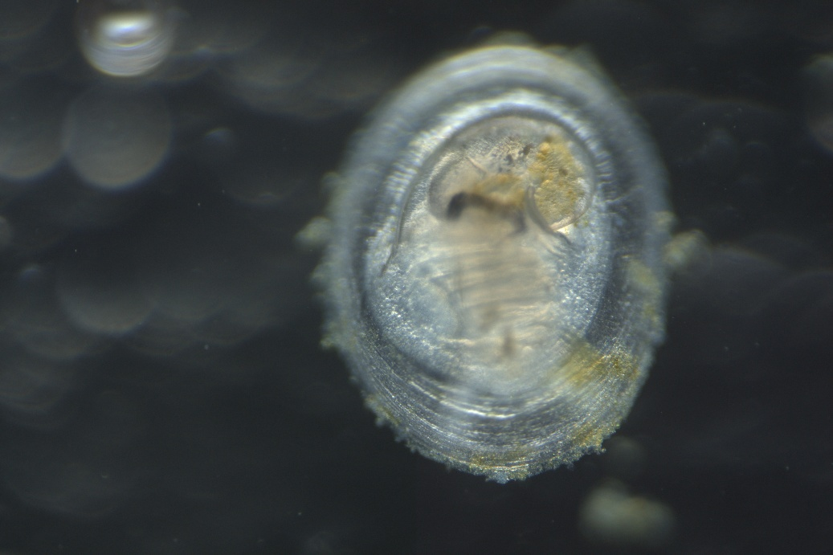
BIOL480/481 – Daily growth rate and growth lines in snails (Webster lab)
11mm Juvenile C. atrasolea with shell growth lines
As animals grow, their growth rate and shape changes gradually (ontogeny). To try and understand how snails grow from their juvenile shell shape into the final adult form, and how growth changes overtime, the Webster lab is looking for a student to help answer these questions. This work would use a time-course of microscope images and learning to use FIJI (ImageJ), a key piece of biological software.
For more information please contact me:
Nicole.webster@usask.ca
Dr. Nicole Webster

