Course title: | BIOL 316 - Molecular Genetics of Eukaryotes
Course code: | CRN 81864 | Term: | T1 Fall 2022
Course credits: | 3.0 | Delivery: | In person
Class session: | 01 | Start Date: | Thu Sept 1, 2022
Lecture room: | ENG2B51 | Lab room: | Rm G11 Thorvaldson Bldg
Lecture time: | T/Th 10:00am - 11:20am | Lab time: | Wed 1:30 to 4.20pm
Website/notes: | via Canvas | Prerequisites | BIOL226

COURSE SYLLABUS
Land Acknowledgment
The Saskatoon campus of the University of Saskatchewan is on Treaty Six Territory and the Homeland of the Métis. We pay our respect to the First Nation and Métis ancestors of this place and reaffirm our relationship with one another. I would also like to recognize that some may be attending this course from other traditional Indigenous lands. I ask that you take a moment to make your own Land Acknowledgement to the peoples of those lands. In doing so, we are actively participating in reconciliation as we navigate our time in this course, learning and supporting each other.

Learning Context
Lectures and laboratories for BIOL316 are in person for the Fall 2022, conditional on the fluid public health situation. This syllabus represents a version of BIOL316 for 100% in person instruction (lectures and laboratories), which may need to be adjusted to conform to public health advice as the term progresses.

Course Description
Examines advanced topics in the molecular genetics of eukaryotes. Examples of topics covered include epigenetics, RNA interference or post-transcriptional gene silencing, the role of model organisms in scientific research, organelle genetics, and RNA splicing. The lab will involve a combination of hands-on experimentation, computer-based analysis and student presentations. Prerequisite: BIOL 226.

General learning Outcomes
By the completion of this course, students will be expected to:
- Appreciate the diversity and regulatory complexity of eukaryote genomes.
- Understand the basic strategies and molecular tools used in research at the gene and genome level.
- Understand the role of model organisms in genetics research.
- Be able to read, understand, summarize and present scientific articles.
- Be able to identify a scientific problem and devise experimental approaches to address it.

Note: The University of Saskatchewan Learning Charter is intended to define aspirations about the learning experience that the University aims to provide, and the roles to be played in realizing these aspirations by students, instructors and the institution. A copy of the Learning Charter can be found at: http://www.usask.ca/university_secretary/LearningCharter.pdf. Information on literal descriptors for grading at the University of Saskatchewan can be found at: http://students.usask.ca/academics/grading/grading-system.php.

Course Overview
Lecture Component and Descriptive Learning Objectives
The course consists of lectures delivered in person. The pptx files corresponding to the lecture notes, as any other material in the course, will also be available in the Canvas course page.

Lecture topics:
Module 1 – The Basis of Genetic Analysis
Module 2 – Model Organisms and their Genomes
Module 3 – Mutant Analysis and Gene Function
Module 4 – System Biology and Gene Networks
Module 5 – Molecular Forensics

Module | Lectures | Learning Objectives | Readings | Evaluation
The Basis of Genetic Analysis | 1,2,3,4 | - Understand the rational thinking behind genetic analysis and its analytical tools | Meneely Chp 1  Watson  Ch 5 & 7 | Midterm  / Final Exams
Model Organisms and their Genomes |  | - Understand the most used model organisms in genetics research and their genomes  - Understand the organization, complexity and layers of regulation of the eukaryotic genome and transcriptome. | Meneely Chp 2 | Midterm  / Final Exams
Mutant Analysis and Gene Function | 5,6,7,8, 9 | - Understand the concept of mutation, spontaneous and induced mutation rates and mutagenesis as a tool in genetic research.  - Understand the main approaches in genetic analysis (forward and reverse genetics) in the context of model organisms.  - Understand the types and applications of modified genetic screen strategies and sensitized genetic backgrounds (suppression, enhancement, synthetic lethality, temperature sensitive screens).  - Understand the concept of lethal mutations and genetic balancers.  - Be able to conceptualize a genetic screen strategy to isolate mutants in genes involved in a certain biological process.  - Be able to anticipate the use of genetic balancers and correct genetic markers in the context of screens.  - Understand the basic strategy in mapping genes in the context of human genetic disorders: positional cloning, RFLP markers, chromosome walking, LOD analysis, exon trapping and the use of model organisms as proxy biological systems for functional analysis of candidate disease genes.  - Understand the concept and application of DNA libraries (genomic and cDNA).  - Understand the process of screening for a clone in a library.  - Be able to conceptualize building a library to address a specific biological question. | Meneely Chp 4-9  Watson  Ch 6 & 12 | Midterm  / Final Exams
Systems Biology and Gene Networks | 10,11,12,13,14 | - Understand Whole Genome Sequencing (WGS) strategies and genome assembly (shotgun approach).  - Understand different DNA sequencing technologies, from Sanger sequencing to New Generation Sequencing (NGS) strategies.  - Understand the basic applications of bioinformatics tools for sequence analysis.  - Understand the concept of Systems Biology.  - Understand the experimental design and applications of different microarray approaches and RNAseq for transcriptome analysis.  - Understand the proteomics approaches, technologies and applications.  - Appreciate the distinct roles, benefits and pitfalls that transcriptomics and proteomics have in genetic analysis.  - Understand the importance of non-coding elements in the genome and the rationale of the Encode Project.  - Appreciate the historical context in the discovery of post-translational mechanisms of gene silencing: Co-suppression in Arabidopsis, RNA interference in C. elegans.  - Understand the RNAi pathway, distinct inducers and the role of nucleases (Dicer and Argonauts) and RNA-protein complexes (RISC) in signaling, amplification and RNA degradation / translation inhibition.  - Understand the different inputs of interference: dsRNAs (siRNA) and miRNA genes.  - Understand the application of RNAi strategies in genetics research. | Meneely Chp 10-12  Watson  Ch 9-14 | Final Exam
Molecular Forensics | 21,22,23, 24 | - Understand the concept of molecular fingerprinting (MF) and its application in law enforcement.  - Understand protein polymorphisms used in molecular fingerprinting (blood types, etc)  - Be able to differentiate the molecular markers used in MF (VNTRs, STRs, SNPs) and point to the advantages and limitations of using them in determining molecular profiles.  - Be able to calculate the uniqueness of a DNA profile (likelihood of two profiles arising by chance in a population).  - Understand the technology used in CODIS: banding patterns, multiplex PCR, STR panel tests.  - Understand how allele frequencies in different human populations impact molecular profiling.  - Understand the pitfalls of MF analysis: DNA degradation, PCR and fluorescence scanning artifacts (polymerase slippage, signal bleeding, etc) and DNA contamination issues.  - Understand the challenges and technical improvements to deal with samples with low copy number / degraded templates such as in miniplex reactions.  - Understand the concept of DNA databases and ethical issues associated with it.  - Understand the concept of uniparental inheritance of mitoDNA and Y chromosome DNA and their role in molecular profiling.  - Understand the implications of MF technology and the hunt for ancient DNA (paleoforensics). | Watson  Ch 16 | Final Exam

Laboratory Component

Laboratory experiments:

LABORATORY 1 – Mutagenesis and Complementation in S. cerevisae
LABORATORY 2 – Transgene expression in Drosophila
LABORATORY 3 – Chemotaxis in C. elegans
LABORATORY 4 – RNA interference in C. elegans

Course Schedule

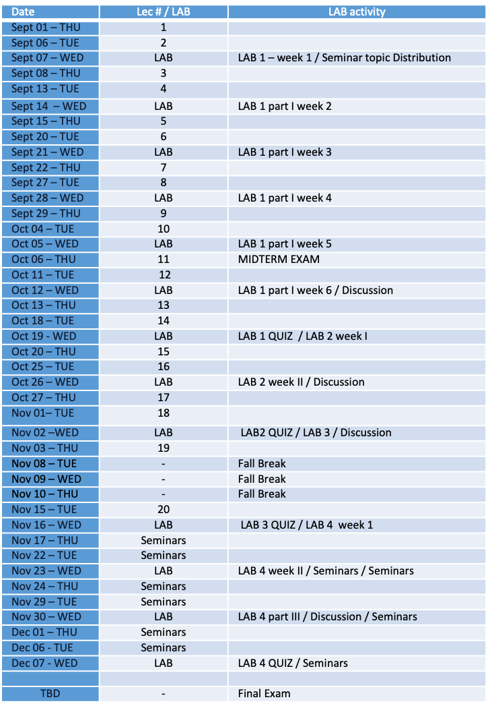

Instructors:

Course Instructor: Dr. Carlos Carvalho

Contact info:
Office: room 220.5 CSRB
Ph# 966-4436
Email: carlos.carvalho@usask.ca
Profile: Dr. Carvalho is a regular faculty member in the Department of Biology. He holds a PhD in genetics and teaches and conducts research in this field of study (http://artsandscience.usask.ca/profile/CCarvalho#/profile).
COURSE TITLE: | BIOL 316 - Molecular Genetics of Eukaryotes
COURSE CODE: | CRN 85328 | TERM: | T1 Fall 2016
COURSE CREDITS: | 3.0 | DELIVERY: | Lecture & Practicum (Lab)
CLASS SECTION: | 01 | START DATE: | 06 Sept 2016
LECTURE LOCATION: | rm 125 Biology Bldg | LAB LOCATION: | Rm B213 Biology Bldg
LECTURE TIME: | 10:30 to 11:20 am | LAB TIME: | Wed 1:30-4:20 pm
WEBSITE: | via Blackboard

Office Hours: Available by email or meetings by appointment.

Lab Coordinator: Dr. Andres Posso-Terranova

Contact info:
Office: room G77 THORV Building
Ph# 966-4431
Email: andres.posso@usask.ca
Profile: Dr. Posso is an evolutionary biologist and laboratory coordinator of genetics courses in the Department of Biology.

Office Hours: Available by email or meetings by appointment.

Teaching Assistant: Ms. Delanie McEvoy

Contact info: CSRB 2nd Floor
Email: dhm012@mail.usask.ca
Profile: Del is a MSc. student in Dr. Chris Ambrose’s lab. Her work involves plant epidermal cell division and expansion concerning microtubule dynamics in Arabidopsis thaliana.
Office Hours: Available by email or meetings by appointment.

Recommended texbooks

The course is being re-organized around the recently adopted Meneely “Genetic Analysis” textbook. A substantial part of the course content will still use material from the Watson (out of print). If you are planning to purchase a textbook to follow the course, please buy the up-to-date Meneely text.
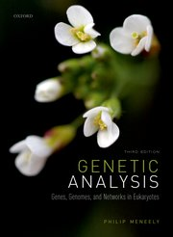
1.Genetic Analysis – Genes, Genomes and Networks in Eukaryotes – 3rd edition. Meneely. 2020.
2.Recombination DNA: Genes and Genomes, A Short Course – 3rd edition. Watson, Caudy, Myers and Witkowski. 2007 (out of print).

The course structure and modules follow mostly the Meneely text. Some of the lecture material will use the Watson textbook, in particular Module 5. When relevant, the instructor will identify the scientific literature used in the notes for further consultation. Copies for consultation of these texts are available in the Natural Sciences Library, though these may not yet be accessible this term due to pandemic restrictions.

On line resources
Lecture notes, laboratory material, and lecture recordings will be accessible through Canvas.

Grading Scheme

Midterm Exam
Value: 25% of final course grade.
Date: Thursday, October 6th from 10:30 to 11:30
Format: 1:30 hour exam. Essay questions.

Final Exam
Value: 40% of final grade.
Date: TBA
Format: 3 hour exam. Mix of multiple choice and essay questions.

Lab Quizzes
Value: 15% of final grade.
4 quizzes based on the class discussion at the end of each laboratory exercise (see schedule for dates).
Format: 35 min quiz. Mix of multiple choice and short answer questions.

Individual Seminars:
Value: 20% of final grade.
Due Date: See Course Schedule.
Format: A 15 min. individual power point presentation. The seminar should introduce an orthodox or emergent model organism chosen in advance by the student and exemplify its research contributions in genetics through the selection and presentation of a relevant scientific article. The article can be in any genetics/developmental/mol biology related field, as long as it explores experimental approaches in modern genetic analysis. Details on the seminar content, structure and evaluation will be provided during the first lab session (Sept 07) together with the assignment of topics.

Attendance Expectations

There are no mandatory components to this course. A final mark of 50% or above is required for passing. No make-up lab quizzes will be offered. Students who miss exams with a reasonable justification can apply to take deferred exams.

Midterm and Final Examination Scheduling

Midterm and final examinations must be written individually and in person at the scheduled dates and rooms. Students who miss the final exam because of no fault of their own or for medical or other valid reasons must contact the College and apply for a deferred final exam. Deferred exam dates are assigned by the Undergraduate Office and exam format may change at the sole discretion of the instructor. Students who miss the Midterm Exam should contact Dr. Carvalho directly for instructions. Students are encouraged to review all University examination policies and procedures:
http://www.usask.ca/calendar/exams&grades/examregs/
University of Saskatchewan Grading System

Students in BIOL 316 are reminded that the University has established a grading system to be used in all of its courses. Information on literal descriptors for grading at the University of Saskatchewan can be found at: http://students.usask.ca/current/academics/grades/grading-system.php

Integrity Defined (from the Office of the University Secretary)

The University of Saskatchewan is committed to the highest standards of academic integrity and honesty. Students are expected to be familiar with these standards regarding academic honesty and to uphold the policies of the University in this respect. Students are particularly urged to familiarize themselves with the provisions of the Student Conduct & Appeals section of the University Secretary Website and avoid any behavior that could potentially result in suspicions of cheating, plagiarism, misrepresentation of facts and/or participation in an offence. Academic dishonesty is a serious offence and can result in suspension or expulsion from the University.
All students should read and be familiar with the Regulations on Academic Student Misconduct (http://www.usask.ca/university_secretary/honesty/StudentAcademicMisconduct.pdf) as well as the Standard of Student Conduct in Non-Academic Matters and Procedures for Resolution of Complaints and Appeals (http://www.usask.ca/university_secretary/honesty/StudentNonAcademicMisconduct2012.pdf)
For more information on what academic integrity means for students see the Student Conduct & Appeals section of the University Secretary Website at:
http://www.usask.ca/university_secretary/pdf/dishonesty_info_sheet.pdf

Examinations through Access and Equity Services for Students (AES)

Students who have disabilities (learning, medical, physical, or mental health) are strongly encouraged to register with Access and Equity Services (AES) if they have not already done so. Students who suspect they may have disabilities should contact AES for advice and referrals. In order to access AES programs and supports, students must follow AES policy and procedures. You must contact AES in advance to request special exam accommodations. Changes in exam dates are not going to be considered as part of these accommodations. If you miss an exam, you can for a deferred exam. For more information, check http://students.usask.ca/current/disability/ or contact AES at 966-7273 or dss@usask.ca.

